NHIS Healthcare Claims and Fraud Dataset — Technical Assessment
This folder contains six related CSV files centered on Nigeria’s National Health Insurance Scheme (NHIS). The primary research file is combined_nhis_dataset_with_fraud_types (1).csv (20,388 rows), published on Kaggle as bonifacechosen/nhis and used in recent fraud-detection papers. The data supports claim-level fraud classification, but it is not a relational healthcare graph dataset in the sense your project requires.

Dataset Inventory
File | Rows | Fraud Labels | Role
combined_nhis_dataset_with_fraud_types (1).csv | 20,388 | Yes (4-class) | Primary file — full labeled dataset
cleaned_nhis_with_fraud_types (1).csv | 4,388 | Yes (3-class) | Curated subset; 1.3% fraud vs 42.6% in combined
simulated_healthcare_claims (1).csv | 20,000 | Yes (4-class) | Separate synthetic dataset; UUID patients, 10 diagnoses
simulated_nhis_healthcare_claims 1(2).csv | 1,500 | Yes (4-class) | Synthetic with explicit Treatment column
data1 (1).csv | 388 | No | Raw extract; subset of combined patient IDs
PROJECT RESEARCH final.csv | 4,000 | No | Raw research export; no Patient ID or fraud column
Recommendation: Use combined_nhis_dataset_with_fraud_types (1).csv as the canonical source unless you explicitly need the treatment-aware synthetic sample (1,500 rows).

1. Available Entities
Project Entity | Present? | Representation | Notes
Patient | Yes | Patient ID | 20,000 unique IDs; 98% of patients have exactly one record
Doctor | No | — | No physician, provider, or prescriber ID anywhere
Hospital | No | — | No facility, clinic, or organization identifier
Insurance Claim | Implicit | Each row ≈ one encounter/claim | No ClaimID; derive synthetic encounter ID from row index
Treatment | Partial / file-dependent | DIAGNOSIS text only in primary files; explicit Treatment in 1,500-row simulated file | Not structured procedure codes; diagnosis often doubles as treatment description
Primary Schema (combined_nhis_dataset_with_fraud_types)
Column | Type | Description
Patient ID | Integer (1–20,388) | De-identified patient
AGE | Float | Age at encounter
GENDER | String | M/F (inconsistent: also m, f, FF, MF)
DATE OF ENCOUNTER | String | Admission/visit start (mixed formats)
DATE OF DISCHARGE | String | Discharge/end date
Amount Billed | Float | Claim amount (₦/local currency; $0–$110,000 range)
DIAGNOSIS | String | Free-text diagnosis (1,771 unique values)
FRAUD_TYPE | String | Target label (multi-class)
Granularity
- 20,388 rows for 20,000 patients → ~1.02 records/patient (only 388 patients have 2 records).
- Each row is best interpreted as a single claim/encounter, not a longitudinal patient record.

2. Possible Graph Nodes
Core nodes (constructible)
Node Type | Key | Count | Features
Patient | Patient ID | 20,000 | Age, gender, encounter count, total billed, fraud history (if transductive)
Encounter / Claim | Derived encounter_id | 20,388 | Amount, length of stay, dates, fraud label
Diagnosis | Normalized DIAGNOSIS | 1,771 | Text embedding, frequency, fraud-rate prior
Optional derived nodes
Node Type | Derivation | Value
FraudType | Label categories | Useful for multi-task learning, not as input node
AgeGroup | Binned age (0–18, 19–30, …) | Demographic clustering
AmountBin | Quantile buckets | Financial anomaly context
Month/Year | From parsed dates | Temporal aggregation
Missing nodes (relative to your project schema)
Patient → Available ✓
Doctor → Not available ✗
Hospital → Not available ✗
Claim → Derivable only ~
Treatment → Diagnosis proxy only ~
There are no provider-side entities, so graphs cannot represent billing organizations, physician networks, or facility-level fraud collusion.

3. Possible Graph Edges
Directly constructible edges
Edge Type | Source → Target | Count | Edge Attributes
had_encounter | Patient → Encounter | 20,388 | —
billed | Encounter → (amount as node feature) | — | Amount Billed, Deductible N/A
diagnosed_with | Encounter → Diagnosis | ~20,350 | Single diagnosis per encounter
diagnosed_with | Patient → Diagnosis | 20,387 unique pairs | Nearly 1:1 with encounters
Weak / derived edges
Edge Type | Construction | Limitation
similar_diagnosis | Diagnosis ↔ Diagnosis via text embedding | No co-occurrence on same claim (single diagnosis only)
similar_patient | Patient ↔ Patient (age, gender, amount) | kNN similarity; not observed relationships
temporal_next | Encounter → Encounter (same patient) | Only 388 patients have 2 encounters
same_date | Encounter ↔ Encounter (shared date) | Weak; no shared provider
Edges not constructible
- Patient/Doctor, Doctor/Hospital, Doctor/Treatment, Hospital/Claim, Provider/Patient
- Diagnosis co-occurrence (no multi-diagnosis per claim)
- Shared-provider or referral networks
Graph topology characterization
The natural graph is a star/bipartite structure:
Patient ──→ Encounter ──→ Diagnosis
(one hop) (one hop)
Average patient degree ≈ 1; average diagnosis degree ≈ 11.5. This is structurally flat, not a rich multi-entity healthcare network.

4. Heterogeneous Graph Feasibility
Technically yes, substantively weak.
Minimum heterogeneous schema

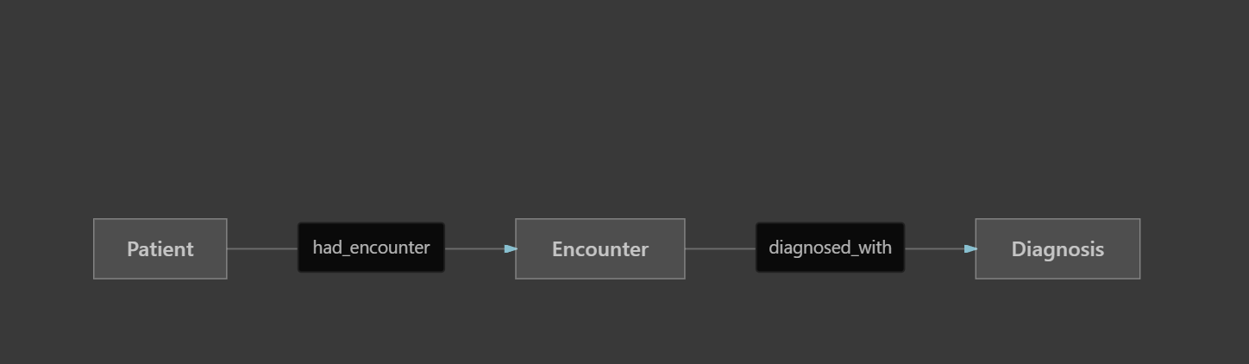

Property | Value
Node types | 3 (Patient, Encounter, Diagnosis)
Edge types | 2–3
Total nodes | ~42,000
Total edges | ~40,000
Graph diameter | 2 (Patient to Diagnosis)
Why it is weak for heterogeneous GNN research
- No multi-type relational paths — no Provider–Patient–Provider or Claim–Physician–Claim meta-paths.
- Near tree structure — almost no cycles or multi-hop reasoning opportunities.
- 1 diagnosis per encounter — no hypergraph or co-occurrence structure.
- 98% single-encounter patients — no temporal chains.
A heterogeneous graph can be built in PyG/DGL, but it adds little beyond tabular features with a diagnosis lookup table.

5. Fraud Labels
Aspect | Status
Labels exist? | Yes — in all labeled files
Label column | FRAUD_TYPE / Fraud Type
Granularity | Claim/encounter-level (matches your project’s claim fraud goal)
Task type | Multi-class classification (+ binary fraud/non-fraud)
Label distribution (combined — primary file)
FRAUD_TYPE | Count | Percentage
No Fraud | 11,704 | 57.4%
Phantom Billing | 4,233 | 20.8%
Ghost Enrollee | 4,099 | 20.1%
Wrong Diagnosis | 352 | 1.7%
Any fraud (binary) | 8,684 | 42.6%
Label semantics (from dataset documentation / IJIRSS 2025 paper)
Label | Intended Meaning | Observable Pattern in Data
No Fraud | Legitimate claim | Non-zero billing; typical amounts (~₦7,900 median)
Phantom Billing | Inflated/unnecessary services | Highest mean amount (~₦15,000); 0% zero-billing
Ghost Enrollee | Non-existent/deceased patient claims | 100% zero billing (Amount Billed = 0)
Wrong Diagnosis | Misclassified condition for higher reimbursement | ~10% zero billing; top diagnoses: pregnancy-related (CYESIS)
Label provenance — critical caveat
Published work states the dataset uses “synthetic fraud patterns in conjunction with” NHIS claim records (Abouelenein et al., IJIRSS 2025). Labels appear rule-injected, not adjudicated by auditors:
- Ghost Enrollee ≡ zero amount (deterministic rule)
- Phantom Billing ≡ high billing amounts
- Wrong Diagnosis ≡ specific diagnosis text patterns (pregnancy codes)
The cleaned subset (4,388 rows) has only 56 fraud cases (1.3%), suggesting manual relabeling — inconsistent with the combined file and unsuitable as an alternate ground truth without documentation.
Train/test split
No official split is provided. Papers use random 80/10/10 splits — acceptable for tabular models but risky for graph models if diagnosis nodes leak across splits.

6. Are Graph Neural Networks Appropriate?
Generally no as a primary method; marginal value at best.
Comparison with your project goals
Project Requirement | NHIS Dataset Fit
Model entity interactions as a graph | Poor — only Patient–Encounter–Diagnosis
Learn hidden relational patterns | Poor — no provider/physician network
Claim-level fraud detection | Good — native label granularity
Explainability (GNNExplainer) | Limited — explanations collapse to diagnosis + amount features
Hybrid GNN + anomaly detection | Weak — insufficient graph structure for meaningful graph autoencoders
When GNN might still be attempted
Approach | Justification | Expected outcome
Diagnosis-centric HetGNN | Learn fraud propagation from diagnosis nodes to encounters | Likely ≤ tabular XGBoost (papers use tree models)
Patient kNN graph + GraphSAGE | Connect patients by diagnosis/amount similarity | Artificial edges; hard to defend in review
Encounter graph with temporal edges | 388 patients with 2 visits | Insufficient temporal depth
What the literature actually uses
Recent papers on this exact 20,388-record file (IJIRSS 2025, IJPS 2025) employ:
- Gradient Boosting / XGBoost (AUC ~0.92)
- Logistic Regression, SVM, Random Forest, Neural Networks
- 27 engineered tabular features (length of stay, amount/day, diagnosis frequency, age bins)
None report GNN benchmarks — likely because the relational signal is too thin.
Verdict
Criterion | Rating
GNN structural justification | Low
Tabular / ensemble ML | High
Anomaly detection (Isolation Forest, Autoencoder on features) | Moderate
GNN + explainability as novel contribution | Low unless combined with richer data

7. Limitations for Publication-Quality Research
Critical limitations
Limitation | Impact
Synthetic / rule-based fraud labels | Labels are partially deterministic (Ghost = $0); inflates achievable AUC; not real adjudication outcomes
No provider/hospital/physician entities | Cannot study collusion, referral fraud, or provider networks — core to insurance fraud research
Flat graph structure | GNN contribution difficult to justify vs. strong tabular baselines already published
Undocumented data provenance | Unclear which fields are real NHIS vs. fully simulated; no IRB or NHIA data-use agreement cited
Inconsistent file versions | Combined (42.6% fraud) vs. cleaned (1.3% fraud) vs. simulated files (different schemas)
Data quality limitations
Issue | Detail
Date formats | Mixed YYYY-MM-DD, DD/MM/YYYY, datetime strings; ~97% parseable with format='mixed', but inconsistent
Gender encoding | Six values: F, M, m, f, FF, MF — requires normalization
Missing values | 2.7% missing encounter dates; 3.2% missing discharge dates; 38 null diagnoses
Diagnosis text | Free-text, non-standard ICD; 1,771 unique strings; high cardinality, noisy
Amount outliers | Max ₦110,000 vs. median ₦7,966
No claim ID | Complicates reproducible encounter referencing
Research / publication limitations
Limitation | Impact
Emerging but narrow benchmark | Kaggle 2024; a few papers (2025); less saturated than CMS Medicare, but limited peer validation
Single geography / payer | Nigeria NHIS only; limited external validity
No temporal fraud evolution | Static snapshot; dates span 2002–2025 but without verified temporal integrity
Class imbalance in cleaned subset | Wrong Diagnosis (352) and Phantom Billing (4,233) highly imbalanced in multi-class setting
Potential label leakage via features | Amount Billed = 0 perfectly predicts Ghost Enrollee — trivial feature leakage
No held-out test with verified labels | All evaluation is random split on same synthetic-labeled corpus
Comparison with CMS Medicare dataset (your other folder)
Dimension | NHIS Dataset | CMS Medicare Dataset
Claim-level labels | Yes | No (provider-level only)
Doctor / hospital entities | No | Physician yes; hospital no
Graph richness | Very low | High
Label authenticity | Synthetic injection | Undocumented “PotentialFraud”
Scale | 20K claims | 558K claims
GNN suitability | Poor | Good
Publication saturation | Low–moderate | High

Proposed Graph Schema
Given structural constraints, two schemas are proposed: a minimal honest schema and an enriched schema (requires synthetic edges — disclose explicitly if used).
Schema A — Minimal (observed data only)
Node Types:
patient (Patient ID)
encounter (encounter_id = row index or hash)
diagnosis (normalized DIAGNOSIS text)
Edge Types:
(patient, had_encounter, encounter)
(encounter, diagnosed_with, diagnosis)
Node Features:
patient: age, gender (encoded), n_encounters, total_billed
encounter: amount_billed, length_of_stay, encounter_month, is_weekend
diagnosis: text_embedding, global_frequency, fraud_type_prior (train only)
Target:
encounter.FRAUD_TYPE ∈ {No Fraud, Phantom Billing, Ghost Enrollee, Wrong Diagnosis}
OR binary is_fraud

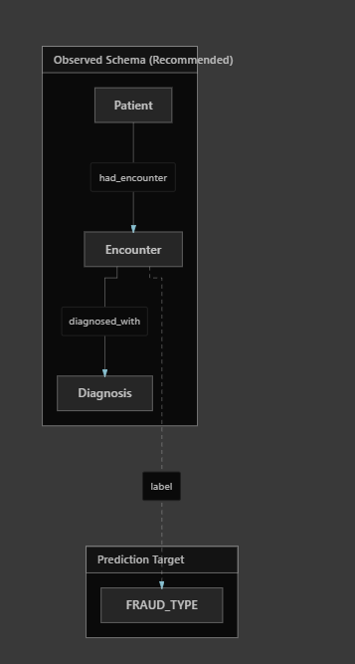

Graph statistics (Schema A):
Metric | Value
Nodes | ~42,159
Edges | ~40,776
Avg patient degree | 1.02
Meta-paths of length ≥3 | None meaningful
Schema B — Enriched (research-only; synthetic edges)
Only if you need heterogeneous GNN depth and explicitly report artificial construction:
Additional Edge Types (derived):
(patient, similar_to, patient) ← kNN on [age, amount, diagnosis embedding]
(diagnosis, similar_to, diagnosis) ← cosine similarity of text embeddings
(encounter, temporal_next, encounter) ← same patient, ordered by date (388 patients)
Additional Node Types (from simulated 1,500-row file only):
treatment (Treatment text)
(encounter, received_treatment, treatment)
(diagnosis, mismatched_with, treatment) ← for Fake Treatment fraud type
Schema B enables meta-paths like Patient–Encounter–Diagnosis–similar–Diagnosis–Encounter–Patient, but reviewers may challenge edge validity.

Suitability Verdict
Criterion | Rating | Summary
Entity coverage | Poor | Patient + claim proxy only; no doctor, hospital, or structured treatment
Graph constructability | Minimal | 3-node-type star graph; not a healthcare relational network
Heterogeneous graph | Yes, but trivial | Formally heterogeneous; structurally near-bipartite
Fraud labels | Good (with caveats) | Claim-level, multi-class; partially synthetic/rule-based
GNN appropriateness | Low | Tabular models dominate; graph adds little structural signal
Publication suitability | Moderate for tabular ML; Low for GNN-centric work | Viable for Nigeria NHIS fraud classification papers; weak for graph-relational fraud research
Bottom line
This dataset is well suited for claim-level fraud classification using feature engineering + ensemble/tabular models, and it aligns better with your claim fraud objective than the CMS Medicare dataset. It is poorly suited for your Graph Neural Network + relational pattern research program because it lacks doctors, hospitals, providers, and multi-entity interactions.
Recommended strategy for your project:
- Use CMS Medicare as the primary GNN graph dataset (rich relational structure).
- Use NHIS as a secondary benchmark for claim-level multi-class fraud with tabular/XAI baselines, or merge NHIS labels onto a richer graph if you obtain provider-linked NHIS data in future.
- If you must use NHIS for GNN, combine it with Schema B enriched edges and compare against XGBoost to demonstrate whether relational modeling adds value — expect null or negative results.
If useful, I can next produce a side-by-side dataset selection matrix for your hybrid GNN + anomaly detection pipeline, or a concrete preprocessing spec for the NHIS combined file.

